PRACTICAL 3 - BI

PROBLEM STATEMENT:

Perform the Extraction, Transformation and Loading (ETL) process to construct the database in SQL Server / Power BI.

1. Program (etl_database.py)
# etl_database.py
import pandas as pd
import sqlite3

# ------------------------------
# 1. Extract Excel (skip metadata)
# ------------------------------
try:
df_excel = pd.read_excel('data.xlsx', skiprows=5) # skip metadata rows
df_excel = df_excel.iloc[:, 1:] # remove first unnamed column
df_excel.columns = ['Project Name', 'Task Name', 'Assigned to', 'Start Date',
'Days Required', 'End Date', 'Progress']
df_excel = df_excel.dropna(how='all') # drop fully empty rows
df_excel.reset_index(drop=True, inplace=True)
df_excel['Progress'] = df_excel['Progress'].fillna(0)
print("Excel Data Preview:")
print(df_excel.head())
except Exception as e:
print("Error reading Excel:", e)
# ------------------------------
# 2. Simulate SQL Server
# ------------------------------
try:
df_sql = pd.DataFrame({
'EmpID': [1, 2, 3],
'EmpName': ['John', 'Jane', 'Mike'],
'Salary': [50000, 55000, 60000]
})
print("\nSimulated SQL Server Data Preview:")
print(df_sql)
except Exception as e:
print("Error simulating SQL Server:", e)

# ------------------------------
# 3. Create SQLite Database
# ------------------------------
try:
conn = sqlite3.connect('etl_database.db')
cursor = conn.cursor()
# Create Project table
cursor.execute('''
CREATE TABLE IF NOT EXISTS Project (
ProjectName TEXT,
TaskName TEXT,
AssignedTo TEXT,
StartDate TEXT,
DaysRequired INTEGER,
EndDate TEXT,
Progress REAL
)
''')
# Create Employee table
cursor.execute('''
CREATE TABLE IF NOT EXISTS Employee (
EmpID INTEGER PRIMARY KEY,
EmpName TEXT,
Salary REAL
)
''')

# ------------------------------
# 4. Load Data into Tables
# ------------------------------
df_excel.to_sql('Project', conn, if_exists='replace', index=False)
df_sql.to_sql('Employee', conn, if_exists='replace', index=False)

print("\nData loaded into SQLite database 'etl_database.db' successfully!")
except Exception as e:
print("Error loading data into SQLite:", e)

# ------------------------------
# 5. Verify Data from Database
# ------------------------------
try:
print("\nProject Data Preview:")
project_data = pd.read_sql_query("SELECT * FROM Project LIMIT 5", conn)
print(project_data)
print("\nEmployee Data Preview:")
employee_data = pd.read_sql_query("SELECT * FROM Employee", conn)
print(employee_data)
conn.close()
except Exception as e:
print("Error reading data from SQLite:", e)

Command to Run
python etl_database.py

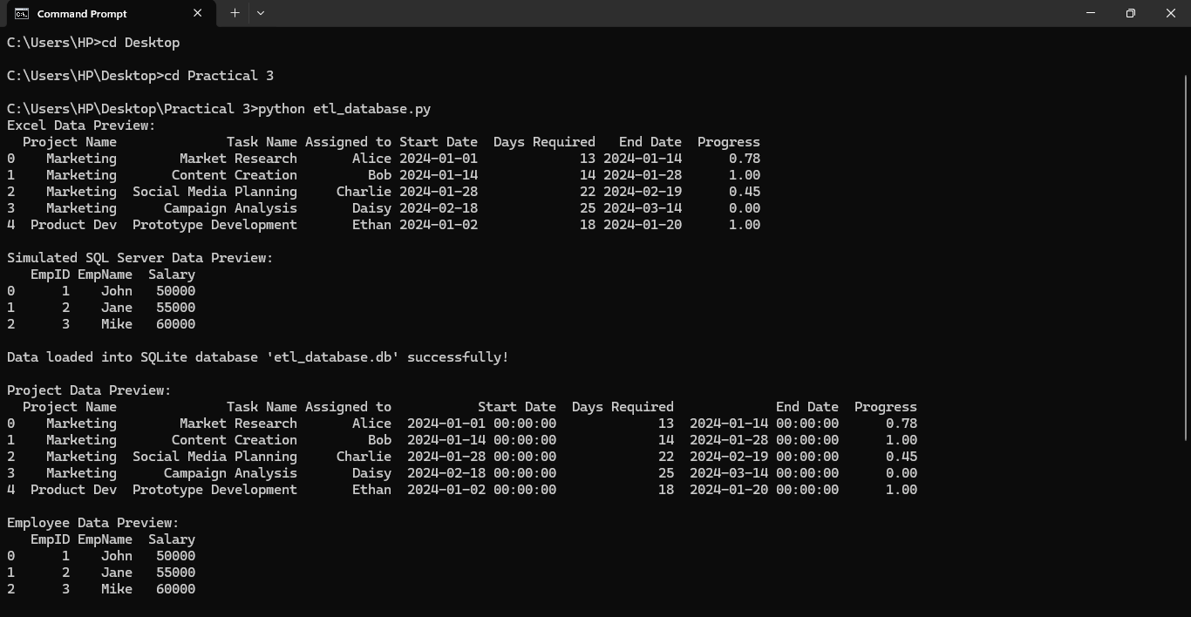
Output

2. Program (view_etl_db.py)
import sqlite3
import pandas as pd

# Connect to database
conn = sqlite3.connect('etl_database.db')

# View Project Table
df_project = pd.read_sql_query("SELECT * FROM Project_Data", conn)
print("Project Data:")
print(df_project.head())

# View Employee Table
df_employee = pd.read_sql_query("SELECT * FROM Employee_Data", conn)
print("\nEmployee Data:")
print(df_employee.head())
conn.close()

Command to Run
python view_etl_db.py

Output
